# Marketing Cloud Integration to Snapchat

### Getting Authentication Credentials

1. First, we must create an OAuth App in Snapchat Ad manager. You need to have access to your Snapchat Ad manager to create one. Under **Business Settings**, click **Business Details** and then click the **+OAuth App** icon the lower part of the page.

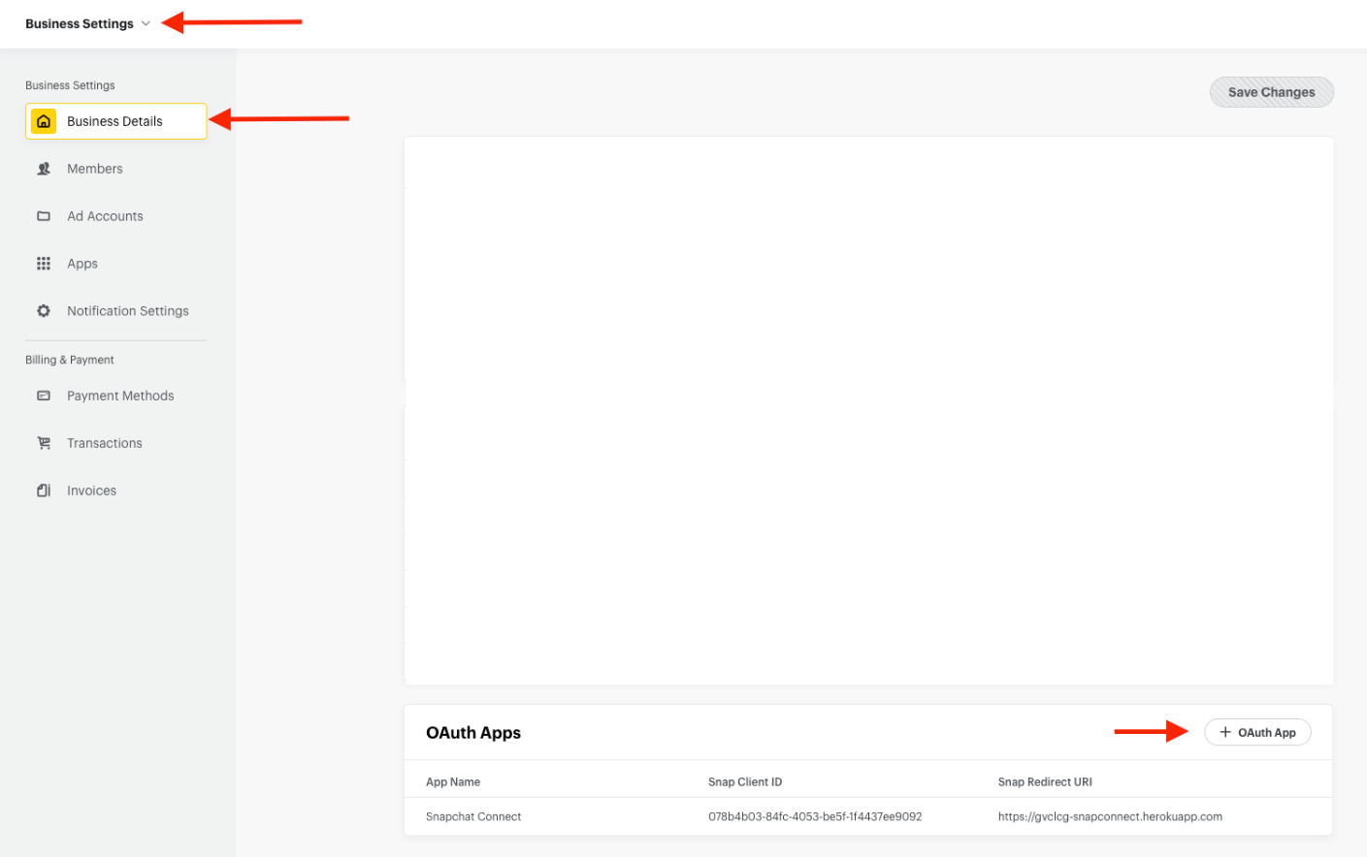

1. You will be prompted to enter App Name and Snap Redirect URI. For the URI, you can use a dummy page. A code will be attached in this URI during authorization process. This will be explained in later part of the documentation. Click **Save**.

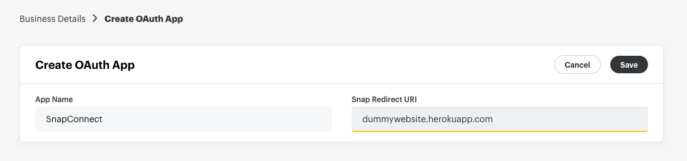

1. Snap Client ID and Snap Client Secret will be provided. Take note of the Client Secret because this will appear ONCE during the app creation so save it. It will be used in authentication process.

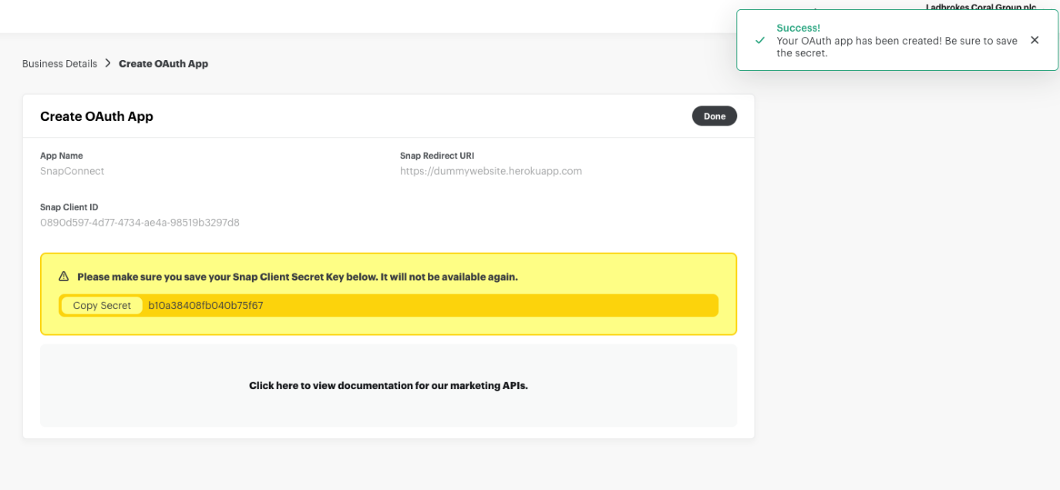

1. Open the authorize link in a browser. Replace the client_id and redirect_uri with the one provided during OAuth app creation.

[https://accounts.snapchat.com/login/oauth2/authorize?response_type=code&client_id=**{client_id}**&redirect_uri=**{redirect_uri}**&scope=snapchat-marketing-api](https://accounts.snapchat.com/login/oauth2/authorize?response_type=code&client_id=%7bclient_id%7d&redirect_uri=%7bredirect_uri%7d&scope=snapchat-marketing-api)

Example:

<https://accounts.snapchat.com/login/oauth2/authorize?response_type=code&client_id=0890d597-4d77-4734-ae4a-98519b3297d8&redirect_uri=https://dummywebsite.herokuapp.com&scope=snapchat-marketing-api>



1. Login & Authorize via UI.

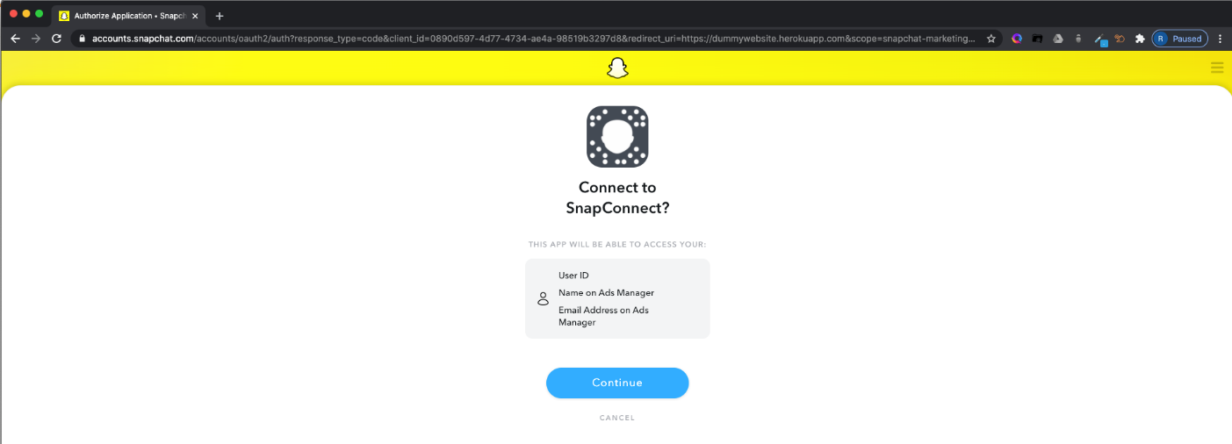

1. Locate "code" query parameter in the redirect



1. Exchange code for access token + refresh token. You can use Postman app to test this.

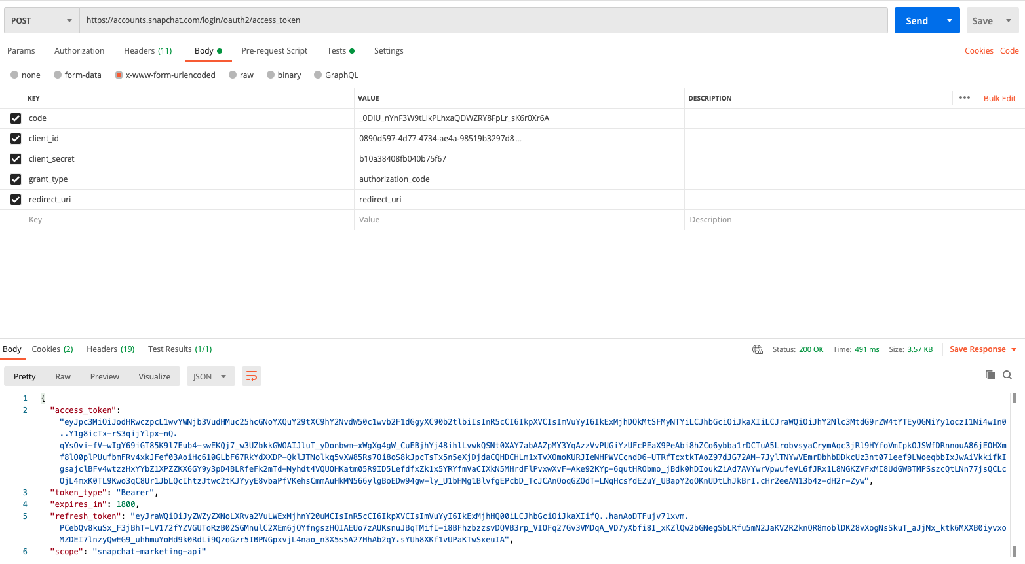

1. When the access token expires, generate a new one using the refresh token

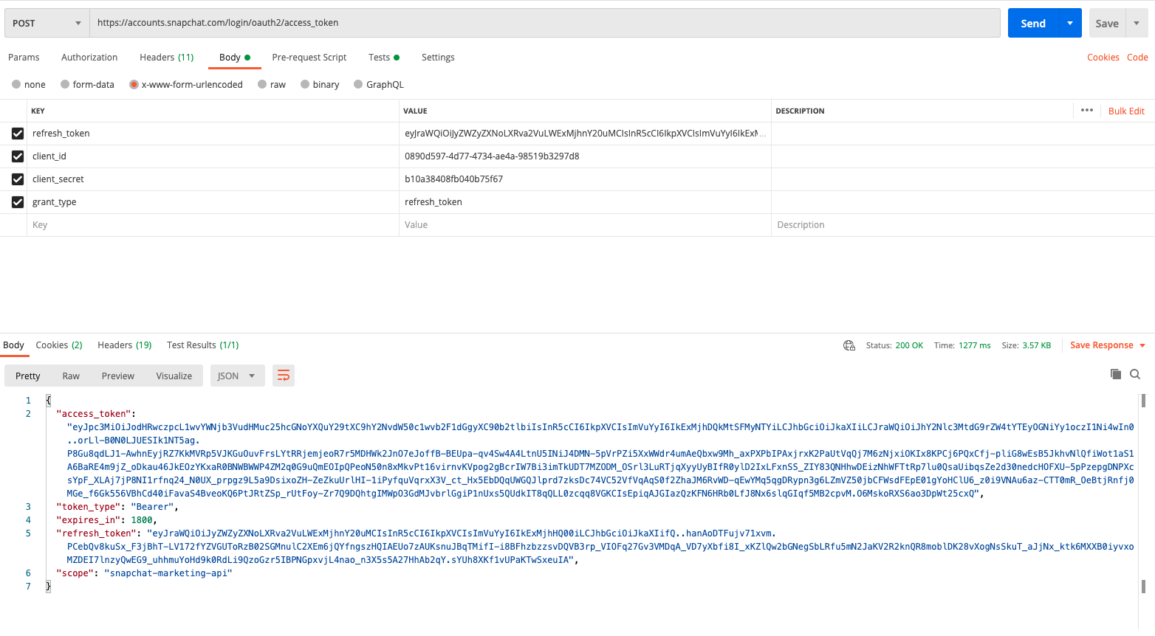

You now have access token you can use in your Snapchat API calls. You will include this access token in the authorization header of your calls as **Bearer <access token>**

Creating New Audience Segment via API

1. Make an HTTP Post request to the following endpoint to create new audience segment in Snapchat with the following authorization header and request body

[https://adsapi.snapchat.com/v1/adaccounts/{ad_account_id}/segments](https://adsapi.snapchat.com/v1/adaccounts/%7bad_account_id%7d/segments)

Parameters

|  |  |  |
| --- | --- | --- |
| **Parameter** | **Default** | **Description** |
| ad_account_id |  | Ad Account ID |

|  |  |
| --- | --- |
| Authorization Header: | Bearer <access token> |
| Request Body: | {  "segments": [  {  "name": "TEST_Ladbrokes_Snap_Segment_API",  "description": "This is a test segment for Ladbrokes Gaming via API",  "source_type": "FIRST_PARTY",  "retention_in_days": 180,  "ad_account_id": "{ad_account_id}"  }  ]  } |
| Expected Response: | |
| {  "request_status": "SUCCESS",  "request_id": "5f4f3a7700ff0836ad8cd1e8ec0001737e616473617069736300016275696c642d37313464326239322d312d3338322d330001012e",  "segments": [  {  "sub_request_status": "SUCCESS",  "segment": {  "id": "5428281582036896",  "updated_at": "2020-09-02T06:23:52.134Z",  "created_at": "2020-09-02T06:23:51.912Z",  "name": "TEST_Ladbrokes_Snap_Segment_API",  "ad_account_id": "d38fa377-f6bd-44e6-b3db-186175bf335a",  "organization_id": "cd1601dc-1d59-4c9d-8dc9-f0b0fc665db4",  "description": "This is a test segment for Ladbrokes Gaming via API",  "status": "ACTIVE",  "targetable_status": "NOT_READY",  "upload_status": "NO_UPLOAD",  "source_type": "FIRST_PARTY",  "retention_in_days": 180,  "approximate_number_users": 0,  "visible_to": [  "AdAccountEntity_d38fa377-f6bd-44e6-b3db-186175bf335a"  ]  }  }  ]  } | |

Adding Users to an Audience Segment via API

1. Users can be added to a segment at any time. The API supports matching via email or mobile identifier.
2. This endpoint will add users to the specified Snap Audience Match Segment using either a single key/identifier per user. We do not accept multiple type of schemas in one request, you need to pass only one schema type with the request, but this needs to happen via a LIST

Attributes

|  |  |  |  |
| --- | --- | --- | --- |
| **Attribute** | **Description** | **Required** | **Possible Values** |
| id | Segment ID | R |  |
| schema | List of one type of Schema | R | EMAIL_SHA256,  //MOBILE_AD_ID_SHA256,  // PHONE_SHA256 |
| data | List of hashed identifiers | R |  |

All user identifiers **MUST BE NORMALIZED AND SHA-256 HASHED** before being transmitted.

### HTTP Request

POST [https://adsapi.snapchat.com/v1/segments/{segment_id}/users](https://adsapi.snapchat.com/v1/segments/%7bsegment_id%7d/users)

Parameters

|  |  |  |
| --- | --- | --- |
| **Parameter** | **Default** | **Description** |
| segment_id |  | Segment ID |

|  |  |
| --- | --- |
| Authorization Header: | Bearer <access token> |
| Request Body: | {  "users": [  {  "id": "{{segment_id}}",  "schema": [  "EMAIL_SHA256"  ],  "data": [  [  "ba8d3ca29ba2890c424197e3dc00760b54cb907ed56dfed6acbed7e3476a3e42"  ],  [  "826a73c568dae5b0dc50b576c419f077d90441c0f559072b5740dfa8c9235c37"  ]  ]  }  ]  } |
| Expected Response: | |
| {  "request_status": "SUCCESS",  "request_id": "d5564160-9fec-4f15-bb58-b9b5c139549a",  "users": [  {  "sub_request_status": "SUCCESS",  "user": {  "number_uploaded_users": 2  }  }  ]  } | |

Suggested Approach

Audiences will be created manually for both Marketing Cloud and Snapchat for a more straight forward and easier approach. The suggested approach will have 2 parts: the UI and an automation in Automation Studio.

## Manager UI

* + User can add name of Audience/DE to the list. Audience should be in the same folder inside Marketing Cloud and same Ad Account in Snapchat. User can choose from a dropdown list what Audience from MC to be added and the corresponding Snapchat audience segment.
  + Manager UI will have a separate DE where the audience names and Snapchat audience ID will be saved.

## Automation

The automation will include the following:

* + A Script activity that will get data from audience/DEs. Part of the script activity is writing a query definition that will get only the email address, normalize and hash it.
  + A SQL activity which query definition is from the first script activity will be executed and data will be saved in a master DE. This DE has 4 fields: email, hashed email, audience name and Snapchat audience ID.
  + A Script activity that will get records from the master DE. Format it according to Snapchat API specs and send it to the same Snapchat audience name based on audience name from MC.

Script Activity 1

* 1. Get the list of the audience / DE name and put to an array
  2. Parse the array. Using each audience name
     1. Get the email address from audience DE based on the audience name
     2. Format the data with the records to create an SQL statement including hashing of emails
  3. Repeat step 2 if there are still audience name to process in the array.

SQL Activity

* 1. Run the SQL query created from the Script Activity 1.

### Script Activity 2

* 1. Get the list of the audience / DE name and put to an array
  2. Parse the array. Using each audience name
     1. Get all the matching records from master DE base on the audience name
     2. Format the data with all the records based on the Snapchat API specs in adding users to a segment
  3. Do a http request to send the records to Snapchat audience segment.
  4. Repeat step 2 if there are still audience name to process in the array.